Compte rendu TP4 SQL
Expression de Requête
Requête 2 :
select distinct nomC
from LesReservations
MINUS
select nomC
from LesReservations join lesetapes using(numc) join lesmonuments on (vetape=nomv)
order by 1;
Ça retourne le résultat suivant :
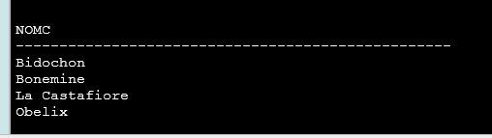
Requête 3:
select nomM,vEtape
from LesMonuments join LesEtapes on (vEtape=nomV) join LesReservations using(numC)
where nomC='Milou';
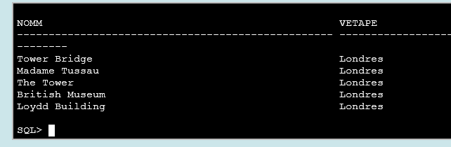
Requête 4:
SELECT vEtape, COUNT(nomM) AS nbMon
FROM LesReservations JOIN LesEtapes USING (numC)
JOIN LesMonuments ON (vEtape=nomV)
WHERE nomC = 'Milou'
GROUP BY vEtape
UNION
SELECT vEtape, 0 AS nbMon
FROM LesReservations JOIN LesEtapes USING (numC)
WHERE nomC = 'Milou'
MINUS
SELECT nomV, 0 AS nbMon
FROM LesMonuments
;
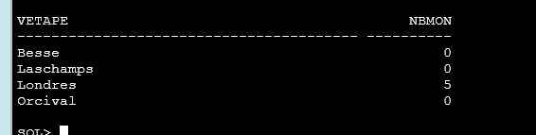

Requête 5:
SELECT DISTINCT numC, vDep, vArr
FROM LesProgrammations JOIN LesCircuits USING (numC)
WHERE dateDep > TO_DATE ('20/12/2000', 'DD/MM/YYYY') ;
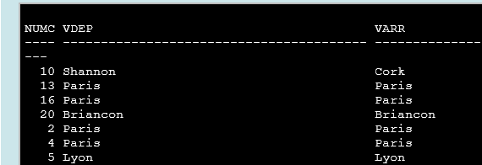
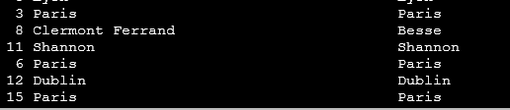



Requête 6:
WITH EtapesParCircuit AS (
SELECT numC, SUM (nbJours) AS nbJoursTot, COUNT(vEtape) AS nbEtapes
FROM LesEtapes
GROUP BY numC),
MaxEtapesParCircuit AS (
SELECT MAX(nbEtapes) AS maxEtapes
FROM EtapesParCircuit
)
SELECT numC, nbJoursTot
FROM EtapesParCircuit JOIN MaxEtapesParCircuit ON (nbEtapes=maxEtapes)

